**DACD LAB EXPERIMENT 7**

**Due: 28-09-2020**

**CED19I027**

1. Implement 4:2 Encoder using Gate ICs

The truth table followed for the Encoder is:

|  |  |  |  |  |  |
| --- | --- | --- | --- | --- | --- |
| I0 | I1 | I2 | I3 | **A** | **B** |
| 1 | 0 | 0 | 0 | 0 | 0 |
| 0 | 1 | 0 | 0 | 0 | 1 |
| 0 | 0 | 1 | 0 | 1 | 0 |
| 0 | 0 | 0 | 1 | 1 | 1 |

From the truth table , we get

**A = (I0)’(I1)’(I2)(I3)’ + (I0)’(I1)’(I2)’(I3)**

**B= (I0)’(I1)(I2)’(I3)’ + (I0)’(I1)’(I2)’(I3)**

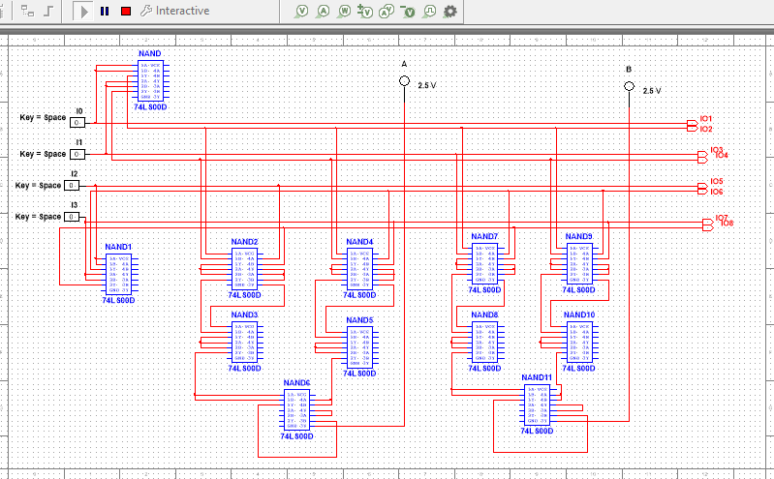

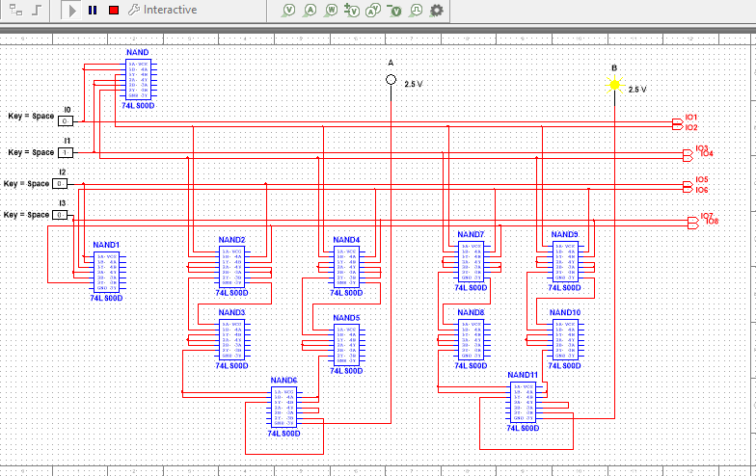

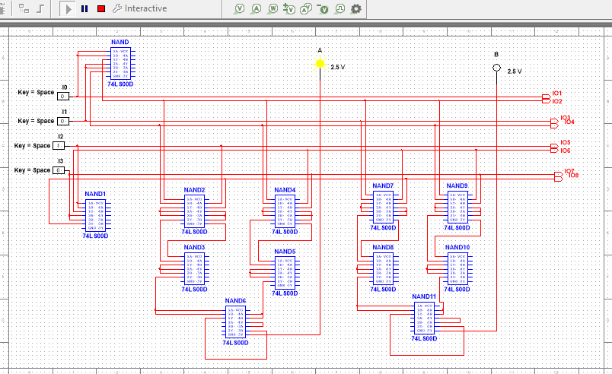

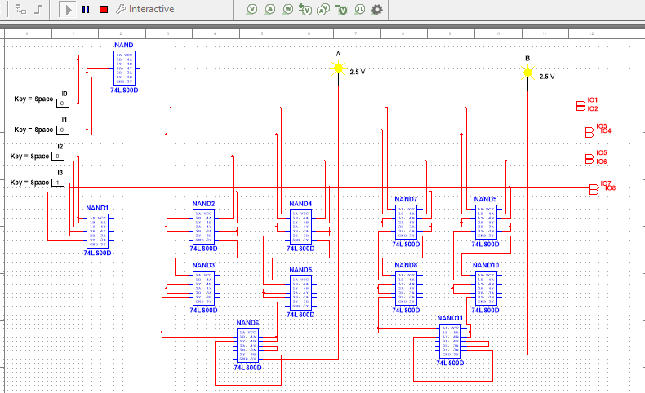

1. Implement 2:4 decoder using gate ICs

The truth table for this is :

|  |  |  |  |  |  |
| --- | --- | --- | --- | --- | --- |
| A | B | **I0** | **I1** | **I2** | **I3** |
| 0 | 0 | 1 | 0 | 0 | 0 |
| 0 | 1 | 0 | 1 | 0 | 0 |
| 1 | 0 | 0 | 0 | 1 | 0 |
| 1 | 1 | 0 | 0 | 0 | 1 |

We get

I0=(A)’(B)’

I1=(A)’(B)

I2=(A)(B)’

I3=(A)(B)

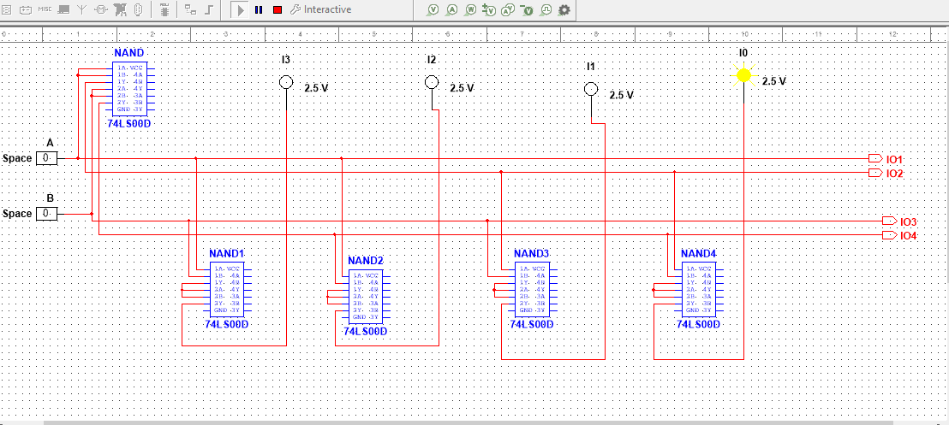

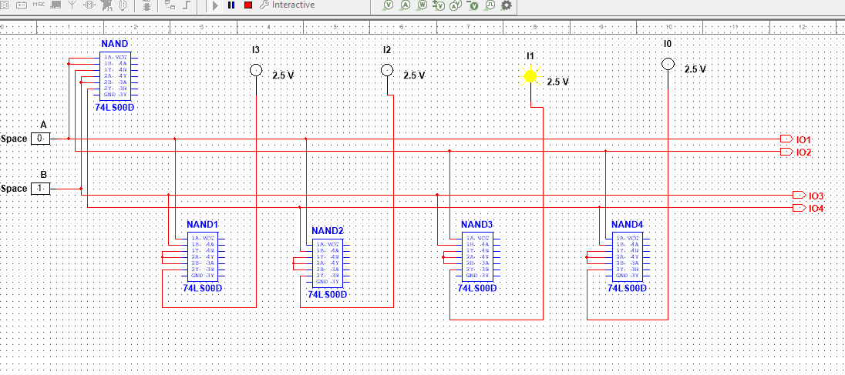

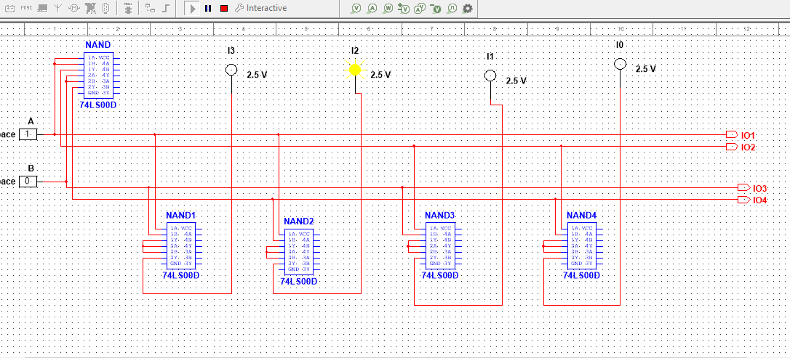

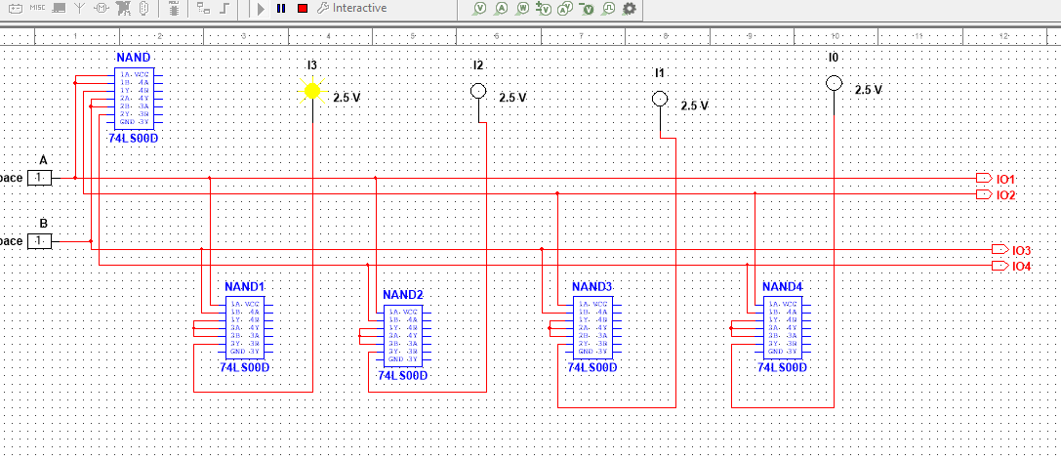

1. Implement Seven segment display using IC7447 decoder(or any equivalent display decoder)

Seven Segment Display is the display showed in digital clocks.

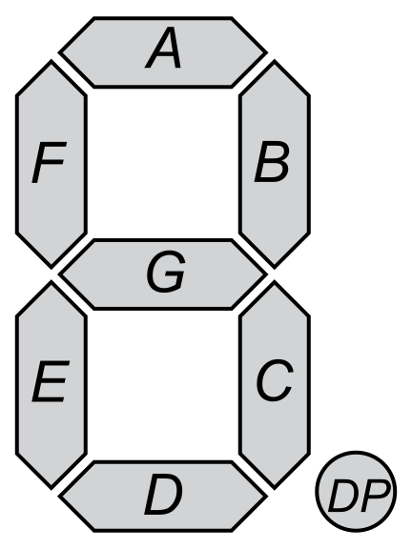 It consists of 7 segments ,namely ,A,B,C,D,E,F,G which are used collectively to display the numbers from 0 to 9.

A seven segment display takes in 4 inputs and determines the glowing of each Segment to display the specified number.

The truth table for seven segment display is as follows:

|  |  |  |  |  |  |  |  |  |  |  |
| --- | --- | --- | --- | --- | --- | --- | --- | --- | --- | --- |
| I3 | I2 | I1 | I0 | **A** | **B** | **C** | **D** | **E** | **F** | **G** |
| 0 | 0 | 0 | 0 | 1 | 1 | 1 | 1 | 1 | 1 | 0 |
| 0 | 0 | 0 | 1 | 0 | 1 | 1 | 0 | 0 | 0 | 0 |
| 0 | 0 | 1 | 0 | 1 | 1 | 0 | 1 | 1 | 0 | 1 |
| 0 | 0 | 1 | 1 | 1 | 1 | 1 | 1 | 0 | 0 | 1 |
| 0 | 1 | 0 | 0 | 0 | 1 | 1 | 0 | 0 | 1 | 1 |
| 0 | 1 | 0 | 1 | 1 | 0 | 1 | 1 | 0 | 1 | 1 |
| 0 | 1 | 1 | 0 | 1 | 0 | 1 | 1 | 1 | 1 | 1 |
| 0 | 1 | 1 | 1 | 1 | 1 | 1 | 0 | 0 | 0 | 0 |
| 1 | 0 | 0 | 0 | 1 | 1 | 1 | 1 | 1 | 1 | 1 |
| 1 | 0 | 0 | 1 | 1 | 1 | 1 | 1 | 0 | 1 | 1 |

From the above truth table , by using k-maps we can evaluate for the equations of A,B,C,D,E,F,G .

For any other combination of I0,I1,I2,I3 ,we donot need truth table as that digit will be double digit and can be represented in BCD system as 2 digits. So rest all values need not be taken care of.

**IC 74LS47D** is the IC used to get the seven segment display

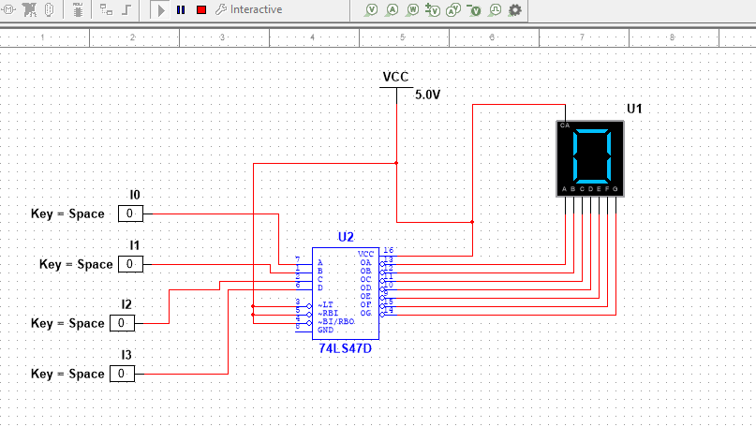

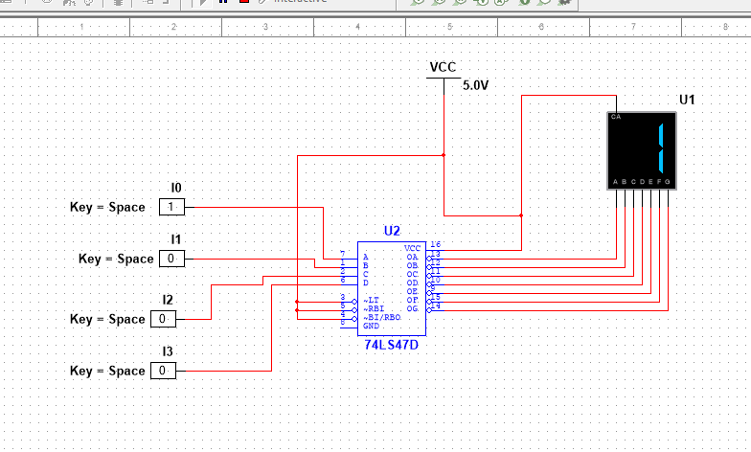

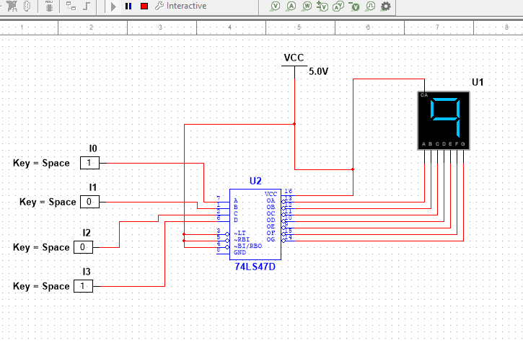

As shown above , display works for all numbers from 0-9.

But for any other values,it either doesn’t display or displays some random shapes as shown below:

